1. AIM: Design PDA using simulator to accept the input string anb2n

INPUT:

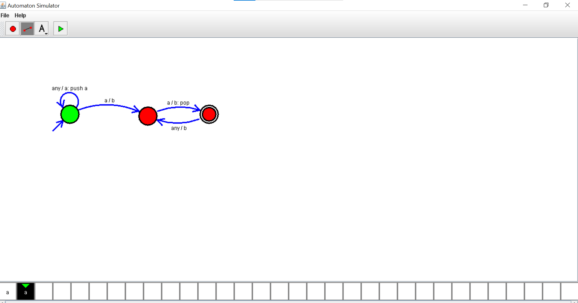

OUTPUT:

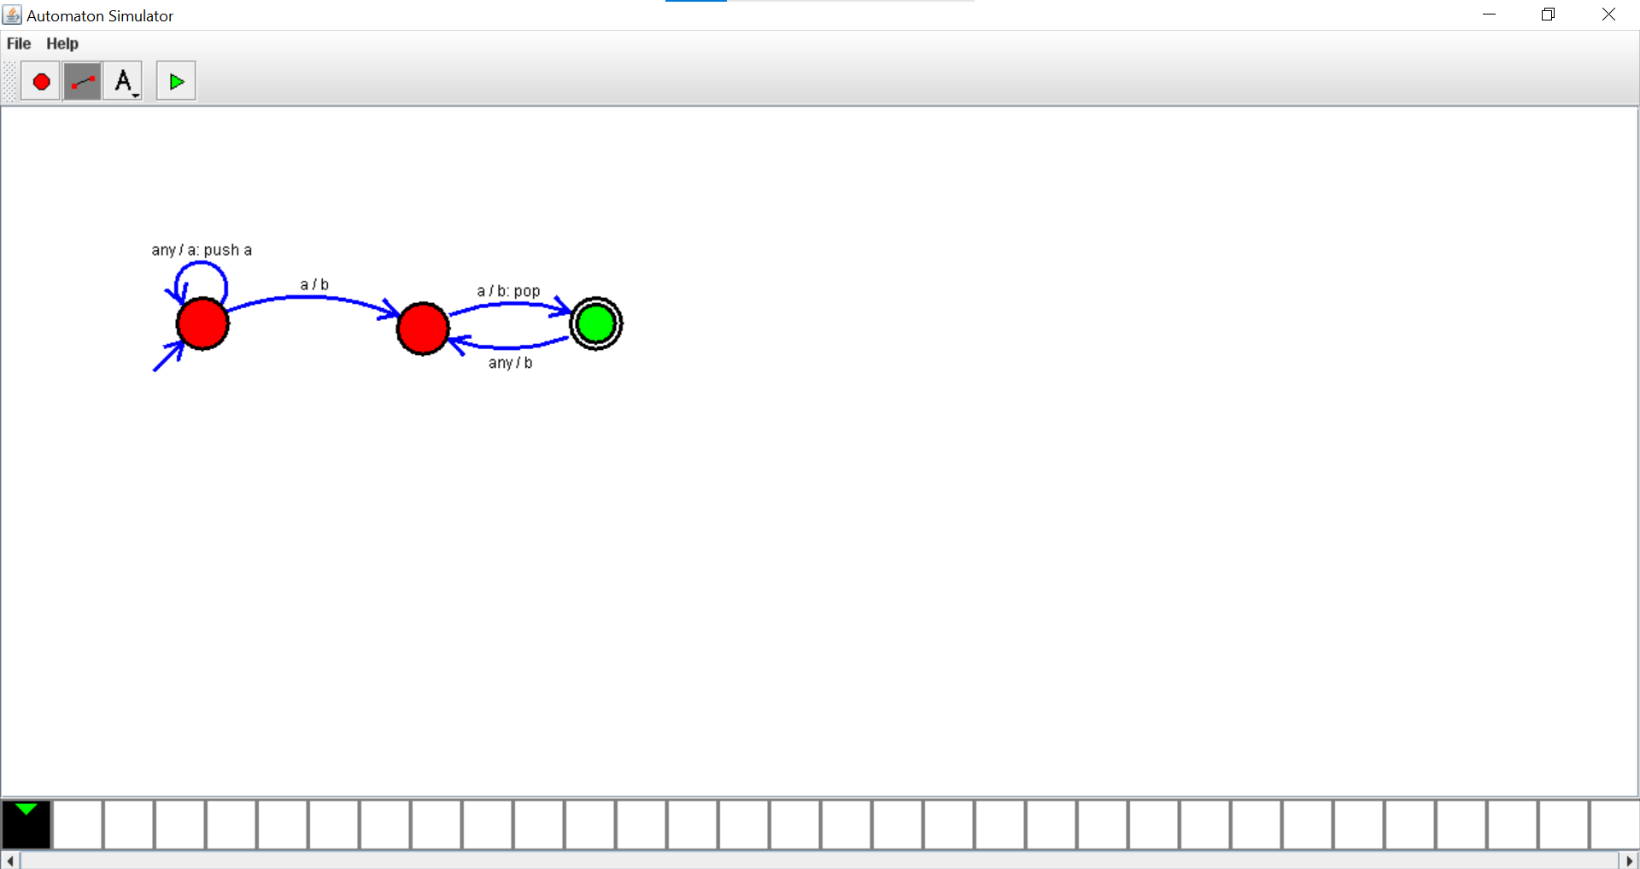

RESULT: thus design PDA using simulator to accept the input string anb2n